

Accessibility Policy 2025

Cumberworth First School recognises and values the diversity of our school community as a rich source which supports the learning of all. We are an inclusive setting and promote tolerance, understanding and equality for all regardless of age, disability, gender reassignment, race, religion or belief, sex, sexual orientation, marriage, civil partnership and pregnancy or maternity.

ACCESS POLICY STATEMENT
Cumberworth recognises that many of its pupils, visitors and staff have individual needs when seeking to make use of the school and facilities. As part of our ongoing commitment to Equal Opportunities and the delivery of an inclusive educational service, Cumberworth will endeavour to ensure that anyone with a disability regardless of their physical limitations will have equal opportunities throughout our site. The plan will be made available online on the school website, and paper copies are available upon request. Our school is also committed to ensuring staff are trained in equality issues with reference to the Equality Act 2010, including understanding disability issues.
Our school’s complaints procedure covers the accessibility plan. If you have any concerns relating to accessibility in school, this procedure sets out the process for raising these concerns.

What is included in this policy
1. Introduction: Purpose and aims
2. Policy detail
3. Additional information to support the policy

Purpose of the Plan
The purpose of this plan is to show how Cumberworth First School intends, over time, to increase the accessibility of our school for anyone with a disability.
The school aims to:
• Plan to make access improvements enabling anyone with a disability to use our services
• Regularly review whether its provision is accessible to all, and take appropriate action.
• Monitor the implementation and effectiveness of this policy on a regular basis.

Our school aims to treat all its pupils fairly and with respect. This involves providing access and opportunities for all pupils without discrimination of any kind.

Policy detail
Definition of Disability The Equality Act 2010 defines an individual as disabled if he or she has a physical or mental impairment that has a ‘substantial’ and ‘long-term’ adverse effect on his or her ability to undertake normal day to day activities. Under the Special Educational Needs and Disability (SEND) Code of Practice, ‘long-term’ is defined as ‘a year or more’ and ‘substantial’ is defined as ‘more than minor or trivial’.

The definition includes sensory impairments such as those affecting sight or hearing, and long-term health conditions such as asthma, diabetes, epilepsy and cancer. Schools are required to make ‘reasonable adjustments’ for pupils with disabilities under the Equality Act 2010, to alleviate any substantial disadvantage that a disabled pupil faces in comparison with non-disabled pupils. This can include, for example, the provision of an auxiliary aid or adjustments to premises. Legal Background This document meets the requirements of schedule 10 of the Equality Act 2010 and the Department for Education (DfE) guidance for schools on the Equality Act 2010 From September 2002, the Disability Discrimination Act 1995 outlawed discrimination by schools and LA`s against either current or prospective disabled pupils in their access to education. It is a requirement that the school’s accessibility plan is resourced, implemented, reviewed and revised as necessary.

Aims
This plan sets out the proposals of the Governing Body of the school to increase access to education for anyone with a disability in the three areas required by the planning duties in the Disability Discrimination Act (1995):
• Increasing the extent to which, anyone with a disability can participate in the school curriculum (this includes teaching and learning) and the wider curriculum of the school such as participation in after school clubs, leisure and cultural activities or school visits.
• Cumberworth aims to treat all stakeholders, pupils, prospective pupils, staff, governors, parents, visitors and other members of the school community favourably, and, wherever possible, take reasonable steps to avoid placing anyone at a substantial disadvantage.
• The school aims to work closely with anyone with a disability, and any relevant outside agencies in order to minimise any potential barriers to learning, which puts them at a disadvantage, thus allowing them to learn, achieve and participate fully in school life.
The school is active in promoting positive attitudes to disabled people and in planning to increase access to education for all disabled pupils.
• As part of the school’s continued communication with parents, carers and other stakeholders we continually evaluate ways to improve accessibility to the site and educational opportunities.

Additional information to support the policy

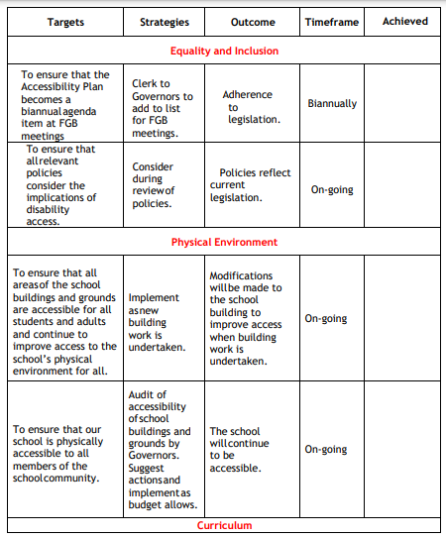

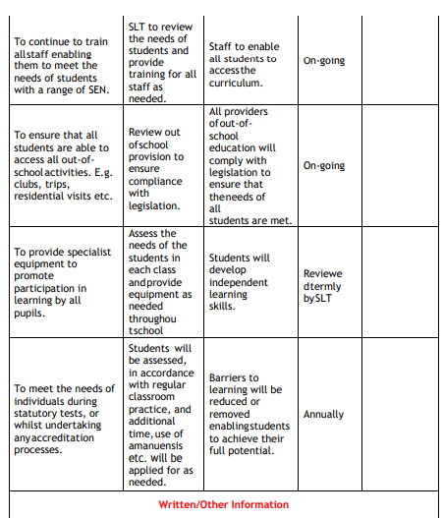
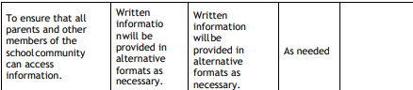

Policy Status
Date reviewed | January 2025
Date of next review | January 2026

