SEND Information Report

Our School   | Our School Vision  At Cumberworth First School we pride ourselves on putting the child and family at the heart of everything we do. We aim to uphold Christian values so that together we can ENJOY our learning, ENRICH our lives and EXCEL by making the most of our talents and gifts.  November 2025 Information  Cumberworth currently has 107 children on roll (September 2025)  There are currently 14 children on SEND register with a range of needs from universal to specialist.  1 child has an EHCP, 1 child has an Individual Assess, Plan, Do, Review Document. We have a number of children for whom we are building a picture of their need. We consider our SEND register to be dynamic and it is regularly reviewed.
How to access the local offer.   | There is a link on the SEND page of our website to the local offer or it can be found :-  https://www.kirkleeslocaloffer.org.uk/
  Meet our SENDCO | Our SENDCo is Ms Robinson. If you would like to speak to Ms Robinson please:-  call 01484 609818 or  email Karen.robinson@cumberworthfirstschool.co.uk  We run drop 6 drop in sessions throughout the year and details of these can be found on our Dojo. If you would like to book an appointment please contact the office 01484 609818.  Our Headteacher Mrs Claxton has overall responsibility for school.
  Special Educational Needs | At Cumberworth we support children with a variety of differing special educational needs and disabilities and we pride ourselves on being a highly inclusive school with an ethos and vision which encourages and celebrates diversity and difference.  SEND need is categorised into the following areas in the SEN code of practise 2014:
   | Cognition and Learning
   | Communication and Interaction
   | Social, Emotional and Mental Health
   | Sensory and Physical
  Identifying and Assessing Need | At Cumberworth we work closely as a team and if staff have a concern about a child, they speak to Ms Robinson and discuss concerns with parents or carers. A child may then be placed on the SEND monitoring register and we begin to follow the Graduated Response approach of ‘Assess, Plan, Do and Review’. We may use a number of specialist assessment tools to support the identification of areas of strength and development and these will be used to guide the decisions taken in relation to provision. If a child joins Cumberworth with an identified SEND need we may add the child to the SEND register without placing them on the monitoring pathway.  After a period of 6 – 8 weeks we will decide if a child needs to be placed on the SEND register and invite parents/carers in for a meeting, where we will share the targets a child is working on and the support they are receiving.  Some children may require more support than is ordinarily available and we may ask outside agencies to support us in ensuring that we are offering the best support we can. This could include referrals to specialist services such as Occupational Therapy, Speech and Language Therapy, our Educational Psychologist.  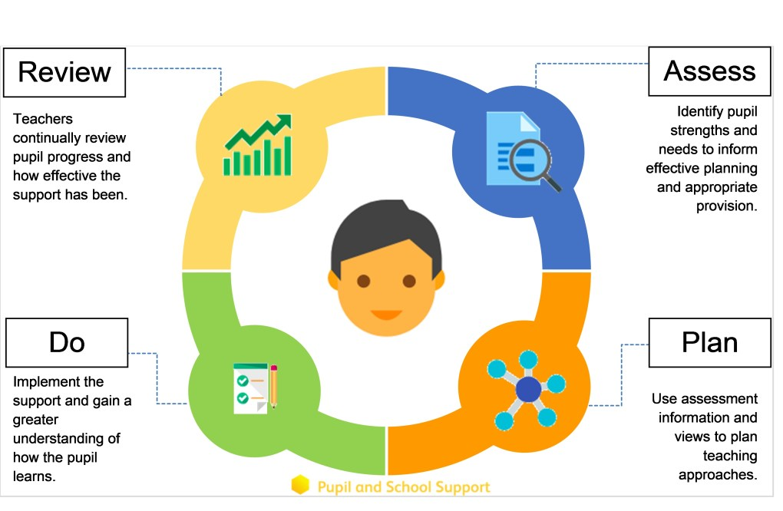
  Our approach to teaching children with SEND | We are an inclusive school. Wherever possible children are taught alongside their peers in flexible teaching groups.  Teachers adapt their high-quality teaching to cater for their pupils’ needs and plan individual timetables where necessary. When appropriate, staff are deployed to give children additional interventions in small groups outside the classroom, or to provide one-to-one support.  We use the EEF guidance ‘Five-a-day’ and embed the key principles into all our lessons.  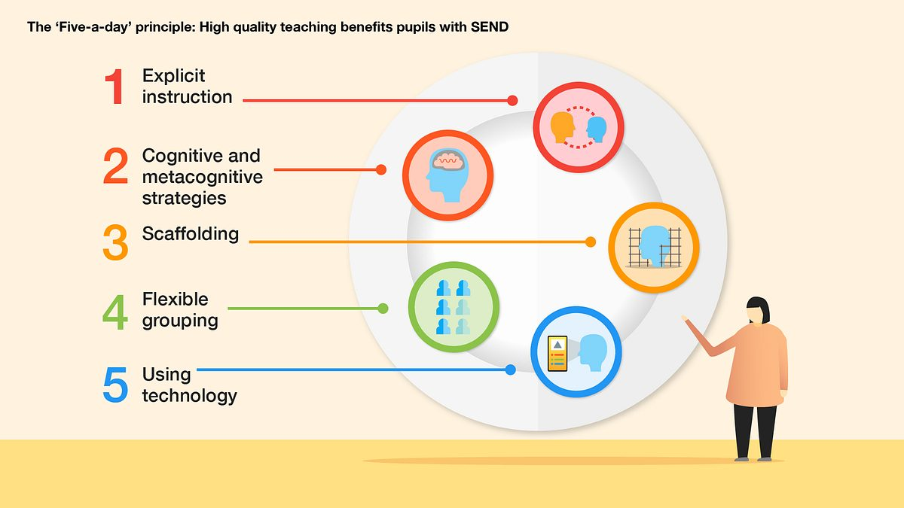
Curriculum adaptations   | We use a range of strategies across our lessons to ensure we offer an inclusive approach to learning and allow all children to access the classroom environment.  We also seek advice and equipment from outside agencies as and when the need arises.
   |  | 
  Visual timetables | Task boards | Peer mentoring
   |  | 
  Assistive technology | Talk partners | Peer marking
   |  | 
  Self-assessment | Word banks | Positive behaviour
   |  | 
  Ear defenders | Timers | Explicit instruction
  Parent Consultations | At Cumberworth we work closely with parents and carers and recognise that they have much to contribute to our support for children with SEND.  We hold drop-in sessions every term and Ms Robinson is available at parents’ evenings to discuss any concerns.  For children who have an Education, Health and Care Plan, My Support Plans (MSP)require specialist support (over and above what is ordinarily available) we will invite you in for 3 further meetings a year in the Autumn, Spring and Summer term. These meeting are used to celebrate a child’s learning, looking at the progress they have made against the targets set, create new targets and discuss next steps. A copy of this will always be sent home after the meetings.  We invite feedback on Provision Plan through opportunities for parents to comment upon provision.  We activity seek parent views to support with co-production of MSP and Individual Assess, Plan, Do, Review documents.
Child Consultations | Pupil’s views are very important; they have a right to be involved in decisions about their education and they are made aware of the support that surrounds them in school.  Children are fully involved and their views feed directly into all policies, procedures and daily teaching of children with SEND.  Pupils are given regular opportunities to:  Pupil voice is captured and reported at least once a year and pupils are asked for feedback on their provision at the end of each term.
   |  | 
  Self-assess how they are doing | Attend meetings and help decide the support needed. | Feedback and Review progress/interventions.
  Evaluating Provision | We frequently review provision in the following ways:-  Review progress in SLT meetings and discussing next steps.  Review SEND children’s progress in pupil progress meetings with the Headteacher.  Discuss and share ideas in staff meetings to ensure up to date research and policy is in place.  Reviewing children’ individual progress towards their goals at regular intervals, as a minimum every term.  Establishing children’s baseline before receiving interventions and reviewing the impact of interventions at regular intervals.  Asking our children if they feel the adjustment or intervention is helpful and makes a difference.  Monitoring by the SENDCO.  Regularly using a tracking tool to update targets and measure progress eg Our Reading Assessment Program.  Holding termly reviews for children who are on Education Health and Care Plans, SEND Support Provision Plans and those requiring specialist support.  Holding annual reviews for children with Education Health Care Plans.
  Staff Training | At Cumberworth, we believe in professional development and aim to ensure all our staff have the understanding they need to enable them to support all child.  When a new member of staff joins the school, we ensure they understand the systems within school and they are given information about the children they are working with.  The senior leadership team within school are constantly moderating needs within the school and, where an area of concern is highlighted, whole school training could be organized to ensure all staff understand specific learning difficulties and appropriate teaching or support strategies that could be utilised. At Cumberworth we have utilised our local outreach services to support with training.  If a child needs specialist support from an outside agency, such as the Speech and Language Service (SALT), Educational Psychologist (EP), Occupational Therapist (OT) or school nurse, we will always discuss this with you first.  Some of our staff have completed training in the following areas. When staff go on a course, they have an opportunity to give feedback to the rest of the staff during staff meeting sessions.
   |  |  | 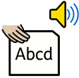
  Autism Awareness | Lego Therapy | Child Development | Tutoring with the Lightning Squad
   |  |  | 
  Specific Learning Difficulties | Complex Needs training | Nurture support | Speech and Language
   |  |  | 
  De escalation | Attachment | Sensory needs | Mental Health and Wellbeing
  Transition Support | Nursery (Pre- School) to Reception  We will conduct a home visit in the summer term for our new reception starters, providing parents with the opportunity to meet with the class teacher and Headteacher.  We hold at least three ‘taster’ sessions in the second half of the summer term in preparation for their September start. School is further open to all pupils on the last day of the summer holidays should pupils wish to visit and reconnect.  Transition to Reception, and then into each successive year-group, is supported by meetings, information leaflets and a transition week in each new class.  End of Year transition  When children move up a year, the last week of term is spent forming our new Team and meeting staff and becoming familiar with new environments.  We hold a weeks transition during the summer term allowing the children to go up to their new classroom and meet their teacher. This will coincide with the Y5 transition to middle school.  Some children may require extra transition visits to their new classroom to help reduce their anxiety and ensure that the transition is successful and positive.  Class teachers and ETAs meet with each other during the summer term to discuss the needs of the children and share Provision Plans.  Mid-Year new starters  When we are aware that pupils joining us from other settings have identified special educational needs, we arrange a meeting with the family to enable us to gain a greater understanding on the support we need to put in place.
  Outside Agencies | We work with the following agencies to provide support for children with SEND:  - Complex communication and interaction team outreach team (CCI)  - Social, emotional and mental health outreach team (SEMH)  - Kirklees Educational Psychology Service  - Occupational therapy services.  - School Health Advisory Service  - Speech and Language Therapy offered through South Kirklees NHS  - CAMHS including the assessment team for the Neurological Developmental Assessment Pathway  - Locala  We will ask parent permission before we arrange for any outside agencies to come in and work with child. Once the feedback has been received we will call you in for a meeting to share the advice.
  Clubs and Trips | All our extra-curricular activities and school visits are available to all our children, including our before-and after-school clubs.  All children are encouraged to go on our trips such as residentials, theatre and day trips.  All children are encouraged to take part in sports day, school competitions, school worships and performances, workshops, etc.  All children are encouraged to apply for roles of responsibility in school e.g. school parliament, librarians, play leaders etc.  No child is ever excluded from taking part in these activities because of their SEN or disability.  Please read the school’s accessibility plan for further information about the steps we have taken to prevent disabled children from being treated less favorably than other children and the arrangements we have made to help children with SEND access our school.
  Wellbeing and Support. | At Cumberworth we take overall wellbeing very seriously.  Support is provided in the following way.  In addition to these specific interventions, we offer a full week of mental health and wellbeing focus to coincide with Children’s mental health week.
   |  | 
  Lego therapy. | Therapeutic writing | Movement club.
   |  | 
  Nessy Reading and Spelling. | Key adult relationships. | Lunchtime clubs.
  Complaint Procedure | The first point of contact is the child’s class teacher.  If you are not satisfied that your concern has been addressed, then you may make an appointment to speak to our SENDCO – Ms Robinson. If they cannot solve your issue, then an appointment can be made to speak to the Headteacher- Mrs Claxton.  If you are not happy with the response, then you may contact the governors through the school office.  Lucy Wilks – Chair of Governors  Jenni Wyrill – SEND Governor

