SEND Information Report 2026

Our School   | School Overview & Contacts  - Head Teacher: Mrs. Fiona Claxton  - Chair of Governors: Mrs. Lucy Wilks  - SENDCo: Ms. Karen Robinson (Email: karen.robinson@cumberworthfirstschool.co.uk)  - SEND Link Governor:  - Address: Cumberworth C of E First School, Cumberworth Lane, Upper Cumberworth, Huddersfield, HD8 8NU  - School Office: 01484 609818 / office@cumberworthfirstschool.co.uk  Our Christian Ethos & Vision  As a Church of England First School, our Christian vision and values are at the heart of everything we do. We put our children and families at the centre of our school community, striving to nurture each child to reach their full potential and fulfil their unique talents. Inspired by Romans 12:6 ("We have different gifts, according to the grace given to each of us"), we aim to Enjoy, Enrich, and Excel together. Underpinning our educational approach are our core Christian values of kindness, love, respect, forgiveness, self-control, and friendship. We ensure every child—including those with SEND—feels valued, supported, and empowered to flourish academically, socially, and spiritually.
How to access the local offer.   | There is a link on the SEND page of our website to the local offer or it can be found :-  https://www.kirkleeslocaloffer.org.uk/
  Special Educational Needs | 1. The Kinds of Special Educational Needs Provided For Our school provides support for pupils across the four broad areas of need outlined in the SEND Code of Practice:  - Communication and Interaction: Speech, Language and Communication Needs (SLCN), Autistic Spectrum Condition (ASC).  - Cognition and Learning: Moderate Learning Difficulties (MLD), Specific Learning Difficulties (SpLD) such as dyslexia or dyscalculia.  - Social, Emotional and Mental Health: Attention Deficit Hyperactivity Disorder (ADHD), anxiety, or emotional self-regulation needs.  - Sensory and/or Physical Needs: Visual Impairment (VI), Hearing Impairment (HI), physical disabilities, or processing needs.
   | Cognition and Learning
   | Communication and Interaction
   | Social, Emotional and Mental Health
   | Sensory and Physical
  Identifying and Assessing Need | School Demographics & Identifying Needs (The Graduated Approach)  - Current Cohort: 100 pupils on roll, with 14 pupils on the SEND register.  - Assess: Class teachers continually assess child progress. If a pupil is not making expected progress despite high-quality teaching, targeted assessments and observations are conducted in consultation with the SENDCo and parents.  - Plan: Specific, measurable outcomes are agreed upon alongside tailored interventions, recorded on an Individual Support Plan (ISP) or an Individual Assess, Plan , Do, Review document (iADPR)  - Do: Interventions and adapted teaching strategies are put into practice daily within the classroom or small group settings.  - Review: Termly progress reviews are carried out with parents, pupils, and school staff to evaluate impact and plan next steps  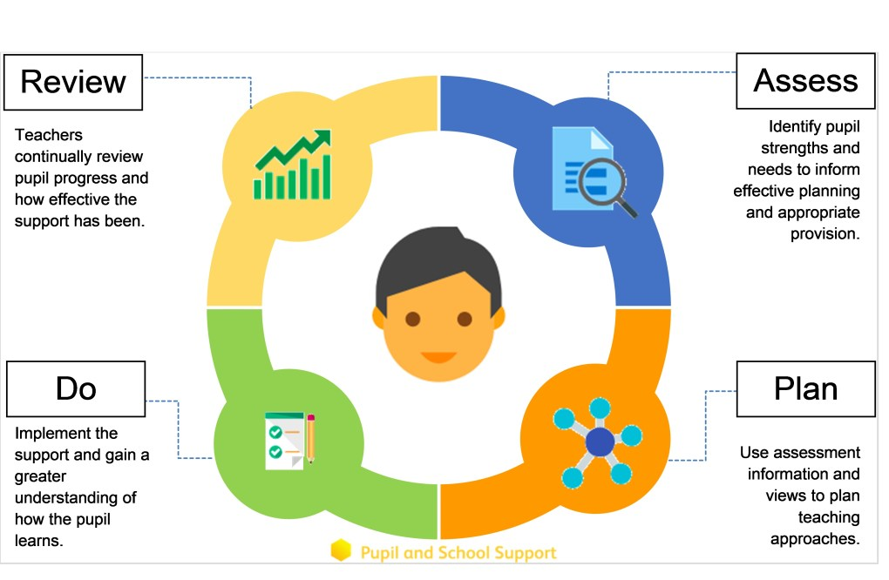  Some children may require more support than is ordinarily available and we may ask outside agencies to support us in ensuring that we are offering the best support we can. This could include referrals to specialist services such as Occupational Therapy, Speech and Language Therapy, our Educational Psychologist.
  Our approach to teaching children with SEND | We are an inclusive school. Wherever possible children are taught alongside their peers in flexible teaching groups.  Teachers adapt their high-quality teaching to cater for their pupils’ needs and plan individual timetables where necessary. When appropriate, staff are deployed to give children additional interventions in small groups outside the classroom, or to provide one-to-one support.  We use the EEF guidance ‘Five-a-day’ and embed the key principles into all our lessons.  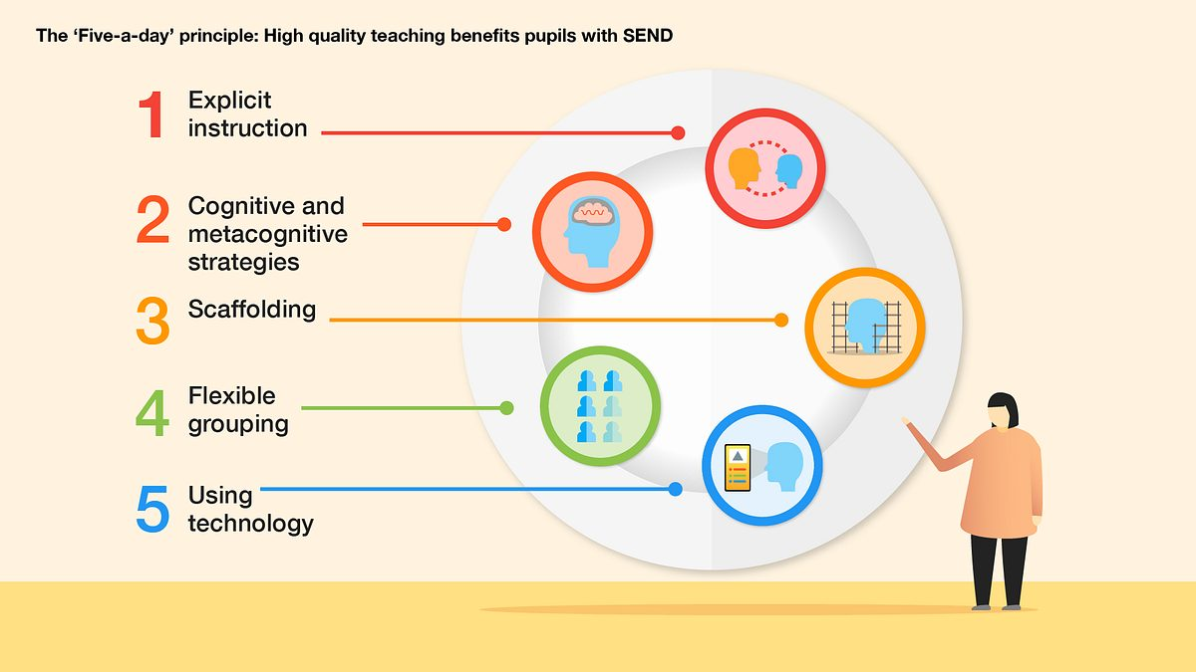
Curriculum adaptations   | We use a range of strategies across our lessons to ensure we offer an inclusive approach to learning and allow all children to access the classroom environment.  We also seek advice and equipment from outside agencies as and when the need arises.
  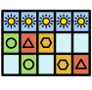 |  | 
  Visual timetables | Task boards | Peer mentoring
   |  | 
  Assistive technology | Talk partners | Peer marking
   |  | 
  Self-assessment | Word banks | Positive behaviour
   |  | 
  Ear defenders | Timers | Explicit instruction
  Parent Consultations | Consulting and Involving Parents: Co-Production & Drop-In Sessions  In keeping with our Christian values of partnership, friendship, and respect, we treat parents as equal partners in their child's education:  - Co-Production of Documentation: We are fully committed to the true co-production of all SEND documentation. Individual Support Plans (ISPs), EHCP applications, and annual reviews are never produced in isolation. Instead, they are co-created alongside parents, carers, and pupils to ensure that family insights, child aspirations, and shared targets form the foundation of all plans.  - Termly Meetings: We meet with parents at least termly to formally review Individual Support Plans (ISPs), evaluate progress, and agree on updated support strategies.  - 6 SEMH/SEND Drop-In Sessions: To build stronger home-school connections and offer accessible, informal support, we run 6 dedicated SEMH/SEND drop-in sessions throughout the academic year (one per half-term). These sessions provide an open, relaxed environment for parents to discuss emotional well-being, share strategies, raise early concerns with the SENDCo, and connect with other families.  - Pupil Voice: We actively gather children's views, feelings, and goals using child-friendly review forms, visual tools, and conversation.
Child Consultations | Pupil Views.  Pupil’s views are very important; they have a right to be involved in decisions about their education and they are made aware of the support that surrounds them in school.  Children are fully involved and their views feed directly into all policies, procedures and daily teaching of children with SEND.  Pupils are given regular opportunities to:  Pupil voice is captured and reported at least once a year and pupils are asked for feedback on their provision at the end of each term.
   |  | 
  Self-assess how they are doing | Attend meetings and help decide the support needed. | Feedback and Review progress/interventions.
  Evaluating Provision | Evaluating the Effectiveness of Provision & Monitoring Progress. The governing body regularly monitors and evaluates SEND provision through:  - Termly Pupil Progress Meetings: Class teachers meet termly with the Senior Leadership Team and SENDCo to scrutinize data, track individual progress for all pupils with SEND, evaluate the impact of active interventions, and adjust support where needed.  - Direct feedback and termly reviews with parents, carers, and pupils.  - Regular tracking of pupil progress data before and after targeted intervention programmes.  - Learning walks, work scrutiny, and annual SEND audits conducted by the SENDCo, Ms. Karen Robinson, and the Senior Leadership Team.  - Annual reporting by the SEND Link Governor, to the full governing body.
  Staff Training | Staff Expertise & Professional Development  - SENDCo Qualifications: Our SENDCo, Ms. Karen Robinson, is currently working towards the mandatory statutory SENDCo qualification (NPQ for SENDCo / NASENCO) and regularly attends local authority network meetings to stay updated on best practices.  - Continuous Professional Development (CPD): All teachers and support staff receive regular training on quality-first teaching, adaptive strategies, and specific SEND needs (such as ASC, SLCN, and SEMH).  - Specialist Staff & External Support: Staff receive ongoing targeted training for specific interventions. Where specialized support is needed, we work closely with Kirklees local authority services  Some of our staff have completed training in the following areas. When staff go on a course, they have an opportunity to give feedback to the rest of the staff during staff meeting sessions.
   |  |  | 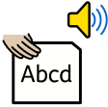
  Autism Awareness | Lego Therapy | Child Development | Tutoring with the Lightning Squad
   | 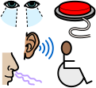 |  | 
  Specific Learning Difficulties | Complex Needs training | Nurture support | Speech and Language
   |  | 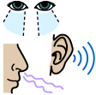 | 
  De escalation | Attachment | Sensory needs | Mental Health and Wellbeing
  Transition Support | Transition Between Key Stages and Schools We ensure smooth transitions through tailored transition plans, additional school visits, photo books, and thorough handover meetings between staff and external agencies when children move classes, start nursery/reception, or transition to middle school.  Nursery (Pre- School) to Reception  We will conduct a home visit in the summer term for our new reception starters, providing parents with the opportunity to meet with the class teacher and Headteacher.  We hold at least three ‘taster’ sessions in the second half of the summer term in preparation for their September start. School is further open to all pupils on the last day of the summer holidays should pupils wish to visit and reconnect.  Transition to Reception, and then into each successive year-group, is supported by meetings, information leaflets and a transition week in each new class.  End of Year transition  When children move up a year, the last week of term is spent forming our new Team and meeting staff and becoming familiar with new environments.  We hold a weeks transition during the summer term allowing the children to go up to their new classroom and meet their teacher. This will coincide with the Y5 transition to middle school.  Some children may require extra transition visits to their new classroom to help reduce their anxiety and ensure that the transition is successful and positive.  Class teachers and ETAs meet with each other during the summer term to discuss the needs of the children and share Provision Plans.  Mid-Year new starters  When we are aware that pupils joining us from other settings have identified special educational needs, we arrange a meeting with the family to enable us to gain a greater understanding on the support we need to put in place.
  Outside Agencies | We work with the following agencies to provide support for children with SEND:  - Complex communication and interaction team outreach team (CCI)  - Social, emotional and mental health outreach team (SEMH)  - Kirklees Educational Psychology Service  - Occupational therapy services.  - School Health Advisory Service  - Speech and Language Therapy offered through South Kirklees NHS  - CAMHS including the assessment team for the Neurological Developmental Assessment Pathway  - Locala  We will ask parent permission before we arrange for any outside agencies to come in and work with child. Once the feedback has been received we will call you in for a meeting to share the advice.
  Clubs and Trips | All our extra-curricular activities and school visits are available to all our children, including our before-and after-school clubs.  All children are encouraged to go on our trips such as residentials, theatre and day trips.  All children are encouraged to take part in sports day, school competitions, school worships and performances, workshops, etc.  All children are encouraged to apply for roles of responsibility in school e.g. school parliament, librarians, play leaders etc.  No child is ever excluded from taking part in these activities because of their SEN or disability.  Please read the school’s accessibility plan for further information about the steps we have taken to prevent disabled children from being treated less favorably than other children and the arrangements we have made to help children with SEND access our school.
  Wellbeing and Support. | Support for Social, Emotional, and Mental Health (SEMH) Guided by our core values of kindness, love, and self-control, we take a proactive, nurturing approach to supporting emotional well-being and social development:  - Robust anti-bullying policies ensuring zero tolerance for discrimination or targeting of pupils with additional needs.  - Targeted pastoral support, quiet break-time options, and social-skills groups.  - Nurture support and individualised emotional regulation plans where appropriate.  In addition to these specific interventions, we offer a full week of mental health and wellbeing focus to coincide with Children’s mental health week.
   |  | 
  Lego therapy. | Therapeutic writing | Movement club.
   |  | 
  Nessy Reading and Spelling. | Key adult relationships. | Lunchtime clubs.
  Complaint Procedure | Handling Complaints Regarding SEND Provision.  If you have concerns about the SEND provision made for your child, please speak to your child’s class teacher or the SENDCo, Ms. Karen Robinson, in the first instance. If your concern is not resolved informally, formal complaints follow our standard timeline:  - Initial formal review by the Head Teacher, Mrs. Fiona Claxton.  - Appeal to the Chair of Governors, Mrs. Lucy Wilks, if unresolved. The full formal Complaints Policy is available on our school website.
External Support Contacts & Local Offer

SEND Link Governor: (Contact via school office)

Kirklees Information, Advice and Support Service (KIAS): Provides free, confidential, and impartial advice for parents/carers. Phone: 01484 416919 | Website: kirkleesiass.org.uk

PCAN (Parents of Children with Additional Needs): Independent parent carer forum in Kirklees. Website: pcankirklees.org

Kirklees Local Offer: Full directory of local authority services at kirklees.gov.uk/localoffer

